**Chapter Four – Part I**

**DIGITAL LIBRARY**

1. **Introduction**

This chapter presents the service based architecture of the first proposed component of the LMS: Digital Library. Digital Library aims to present a digital store for faculty contents that needs to be available for future usage in electronic format. Digital Library can be used to present external available digital books, and digital materials available by the system, like: books authored by internal authors / instructors, under graduate, graduation, and post graduate project’s materials like source code and documentation.

1. **Problem Definition and Proposed Solution**

Most of Students face repeatable situations where they need to make decisions and can not find help. Examples of those situations are:

* Students need to find a database that holds a list and available content of Graduation Projects performed by students of the same faculty from previous years. This Graduation Projects database can be used as guidance to new students to help choosing the right graduation project, besides the capability to search and retrieve the digital contents of those graduation projects.
* Students can find it conflicting to choose between the different departments of the faculty. In order to help students choose the right department, we can provide a structure of courses taught in each department, contents of those courses, and relationships between those materials.

**Proposed Solution:**

* Data base system that holds:
* Under-Graduate Projects
* Graduation Projects
* Post-Graduate Projects

In the electronic format that gives the capability to search within as a Digital Library.

* Present Books authored by Faculty professors in the electronic format; available also as a digital library.
* Present On-Line magazine of the faculty. This magazine is edited, and authored by students’ faculty.
* Present On-Line guide for students to help them choose among different departments in the faculty.
* Present On-Line guide for fresh students with external links to resources that they can consume through the four years of study.
* Present students guide for specialized laboratories in the faculty. There are laboratories made available for Computer Networks, others are made for programming requirements, and so on. Students can use those laboratories.
* Make all available digital contents applicable for online comments by readers.

1. **Digital Library Analysis**

Figure 4.2 presents the Digital Library Use Case. Processes include:

* Review Book
* Review Under Graduate Project
* Review Graduation Project
* Review Post Graduate Project
* Make Under Graduate Project
* Make Graduation Project
* Make Post Graduate Project

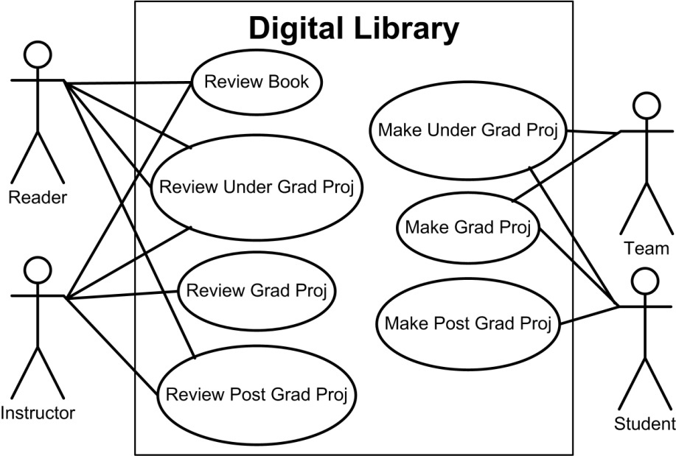

**Figure 4.2: Digital Library Use Case**

1. **Digital Library Design**

Figure 4.3 presents Digital Library entities. Figure 4.4 shows the Entity Relationship (E-R) diagram of Digital Library.

* 1. **Proposed Digital Library Architecture**

Figure 4.5 (a,b) depicts the proposed entity centric – services based Digital Library architecture. Part (a) covers Student, Reader Review, Author/Instructor, Publisher, Book, and Team managers. Every manager lies in the Orchestration layer; that is a sub layer of the Services layer, and consumes application services layer insert, update, delete, and select services. Part (b) presents Topic, Chapter, Project, and Course managers.

**Figure 4.3: Digital Library Entities**

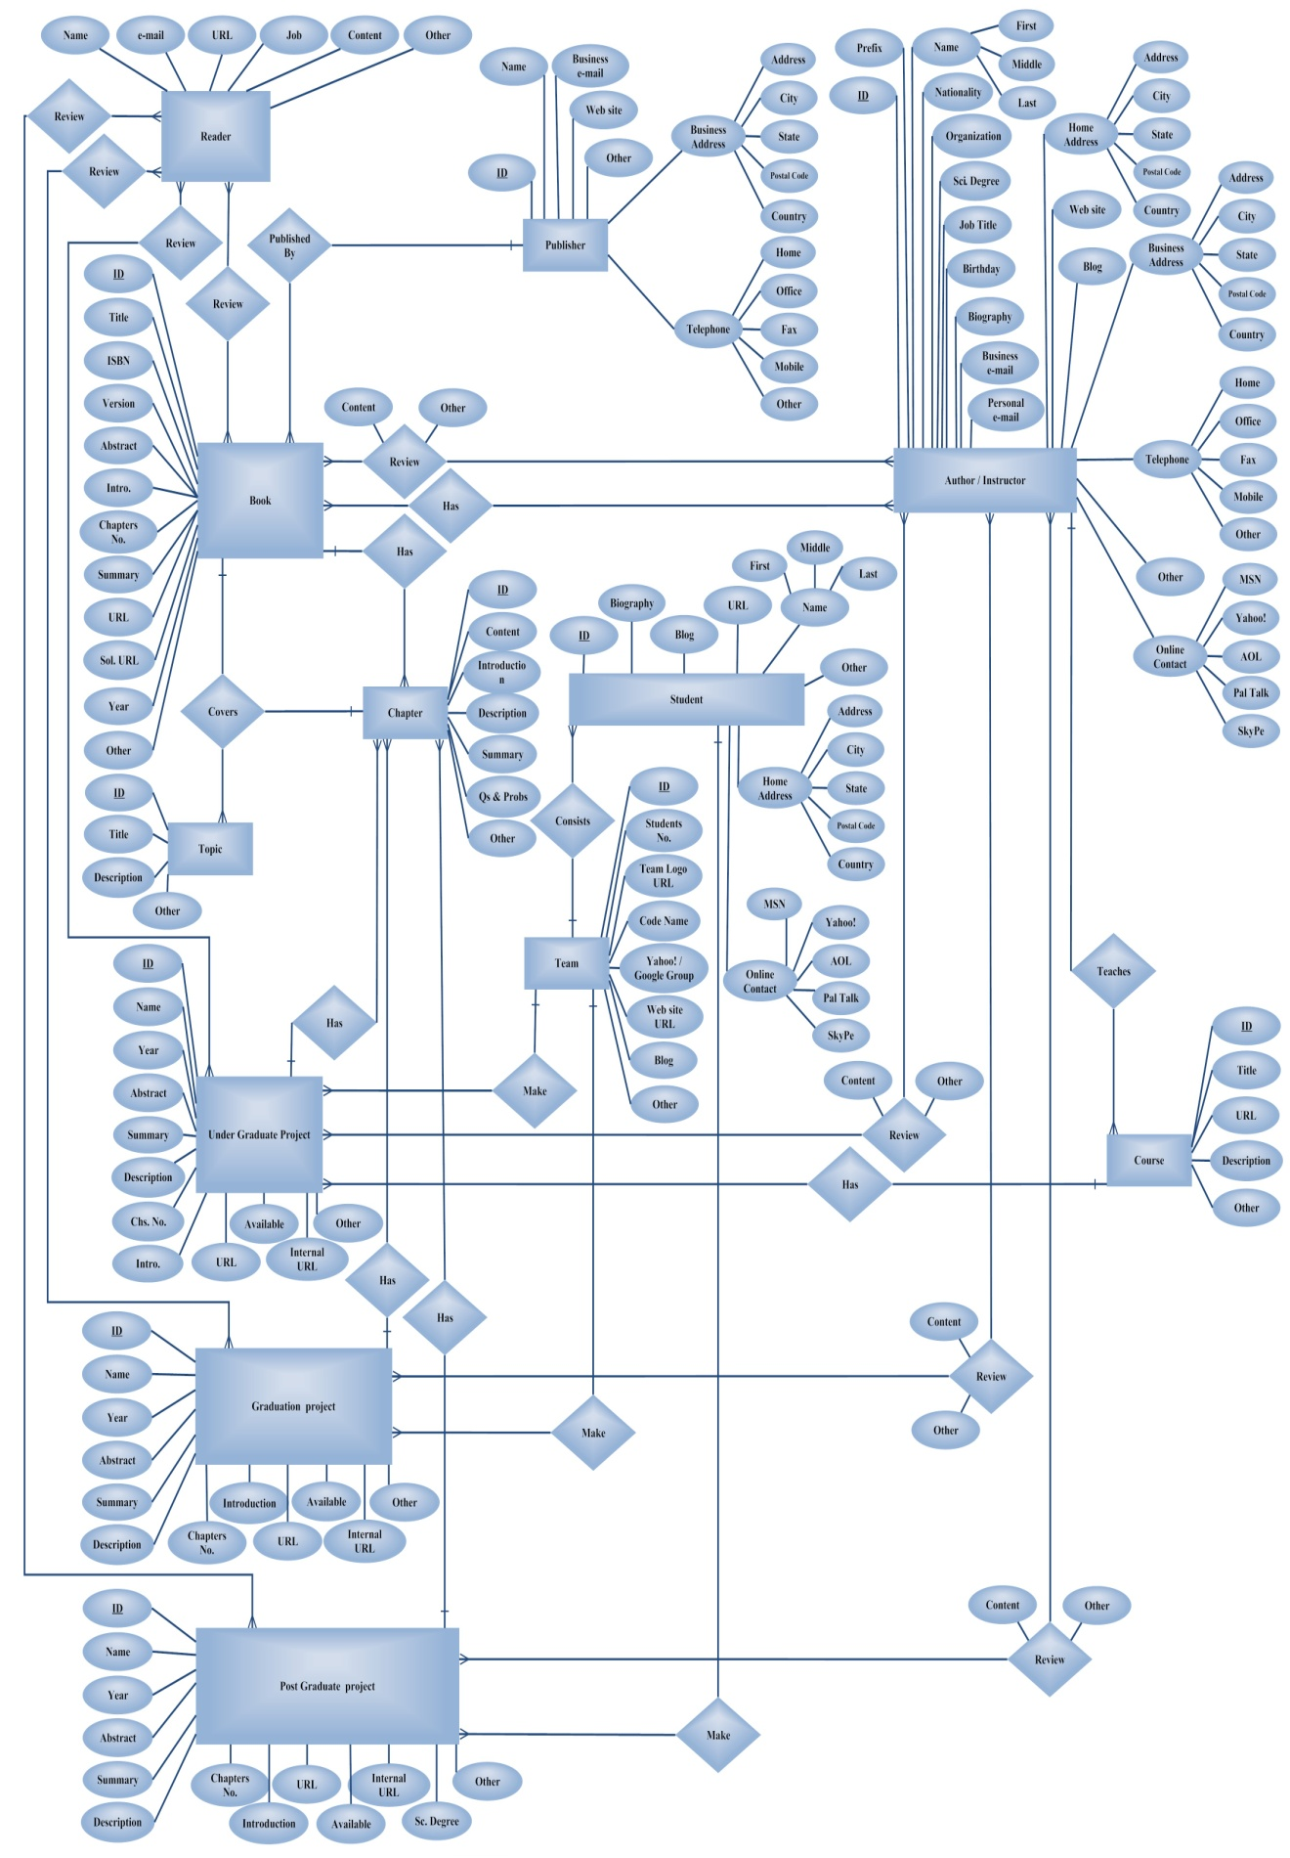

**Figure 4.4: Digital Library Entity-Relationship (E-R) Diagram**

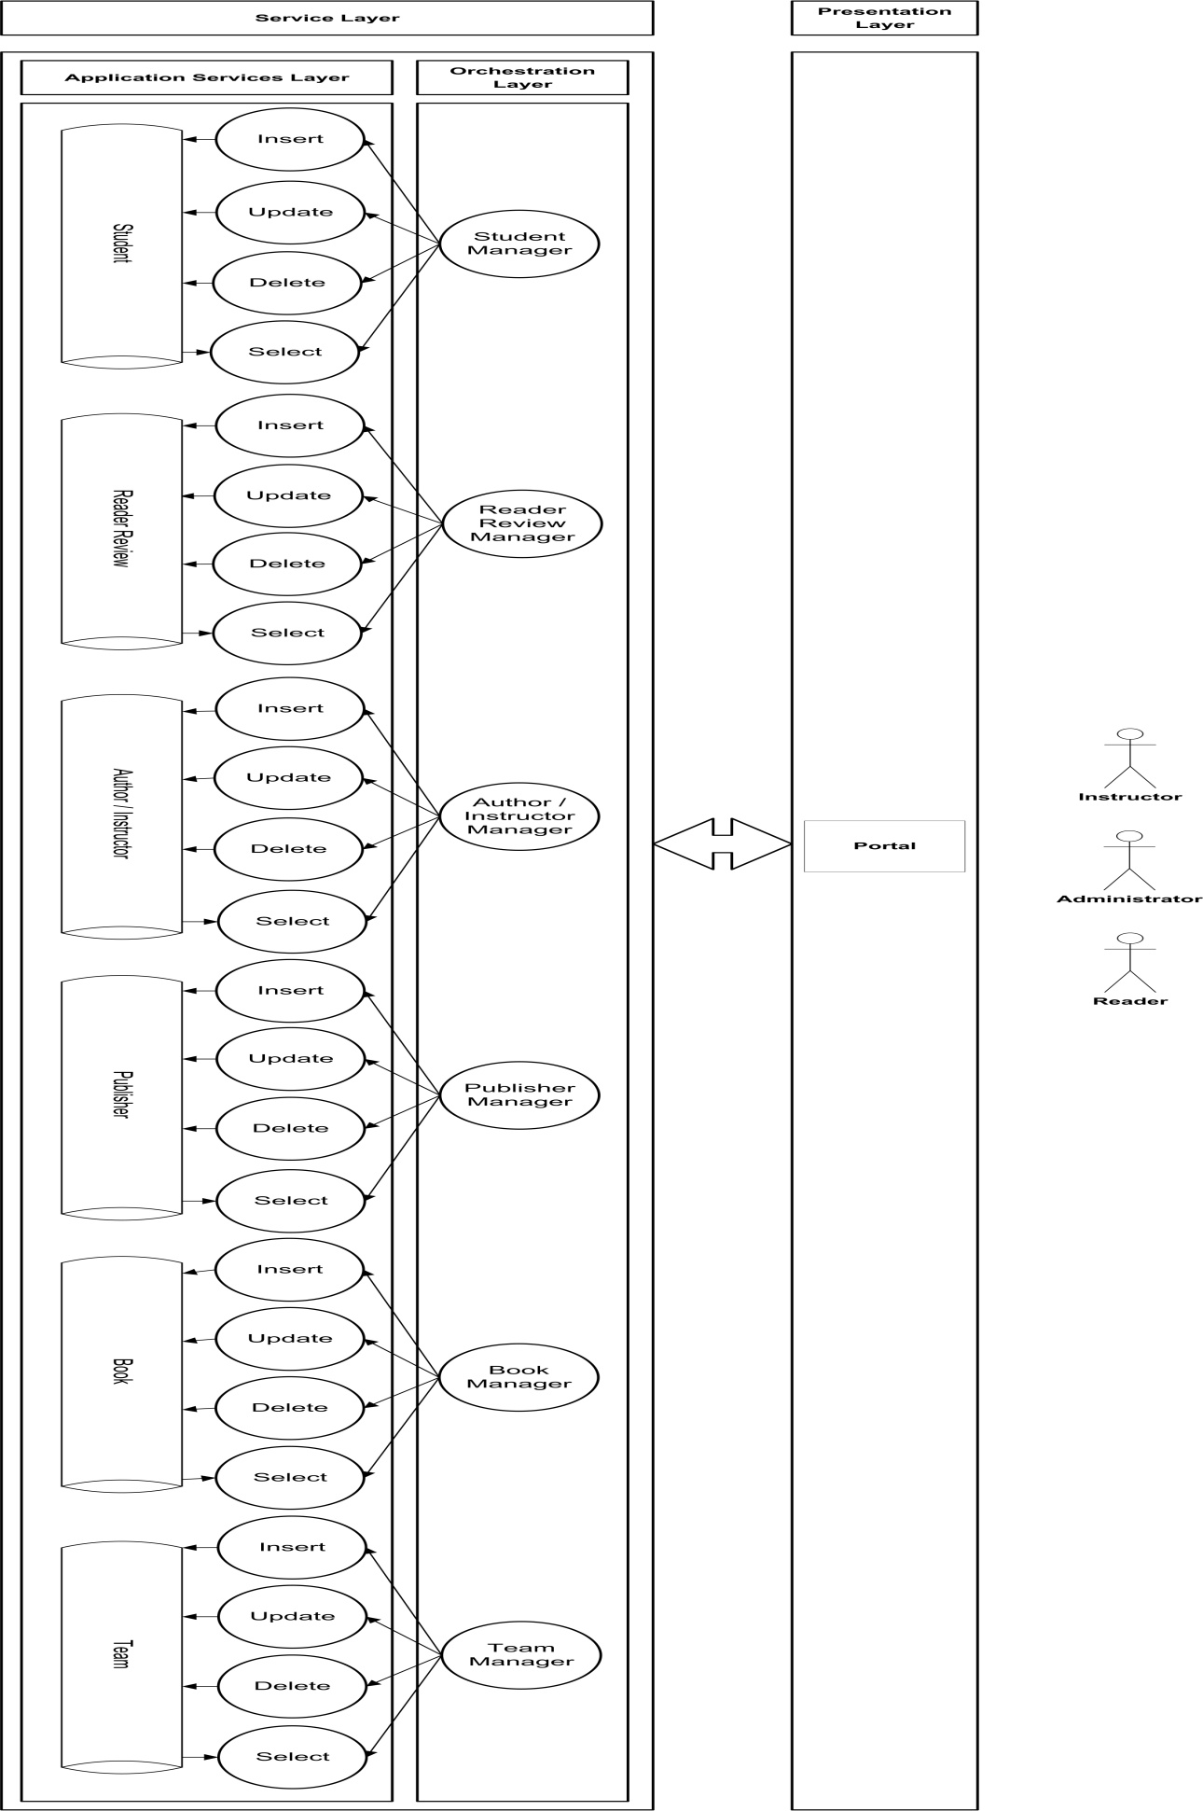

**Figure 4.5 (a): Digital Library Proposed Architecture**

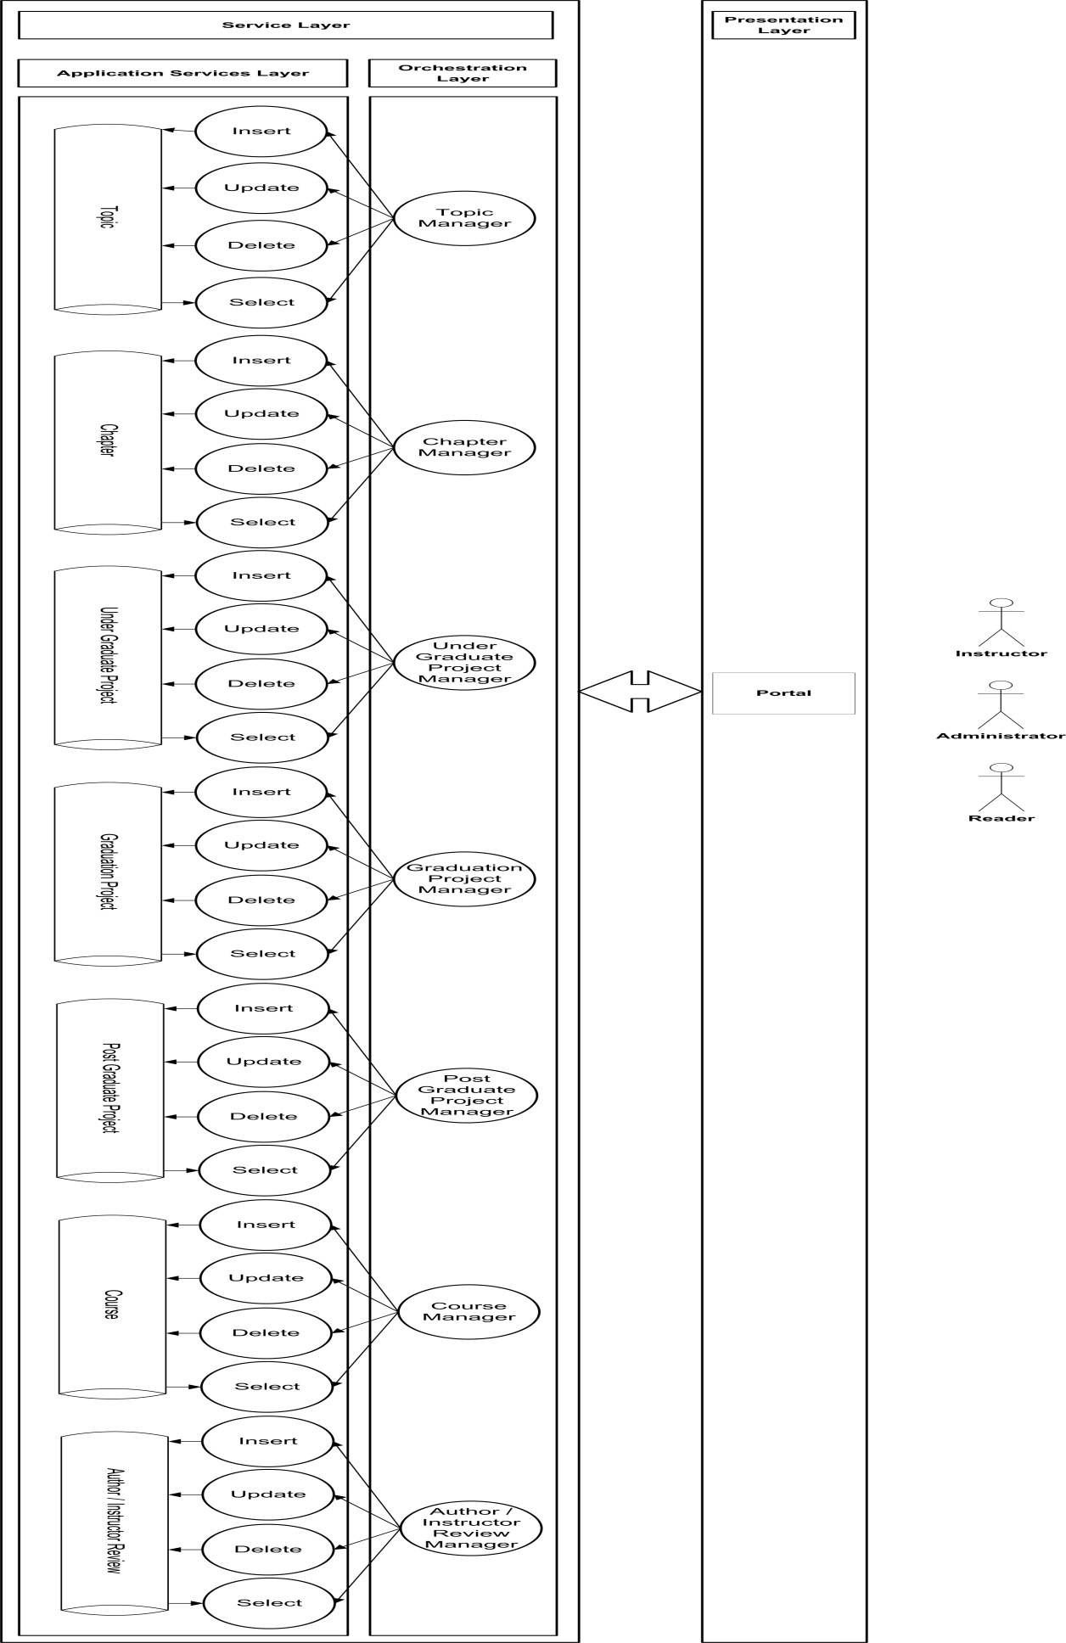

**Figure 4.5 (b): Digital Library Proposed Architecture**

**4.2 Digital Library Database Tables**

Figure 4.6 presents the implemented database tables of Digital Library.

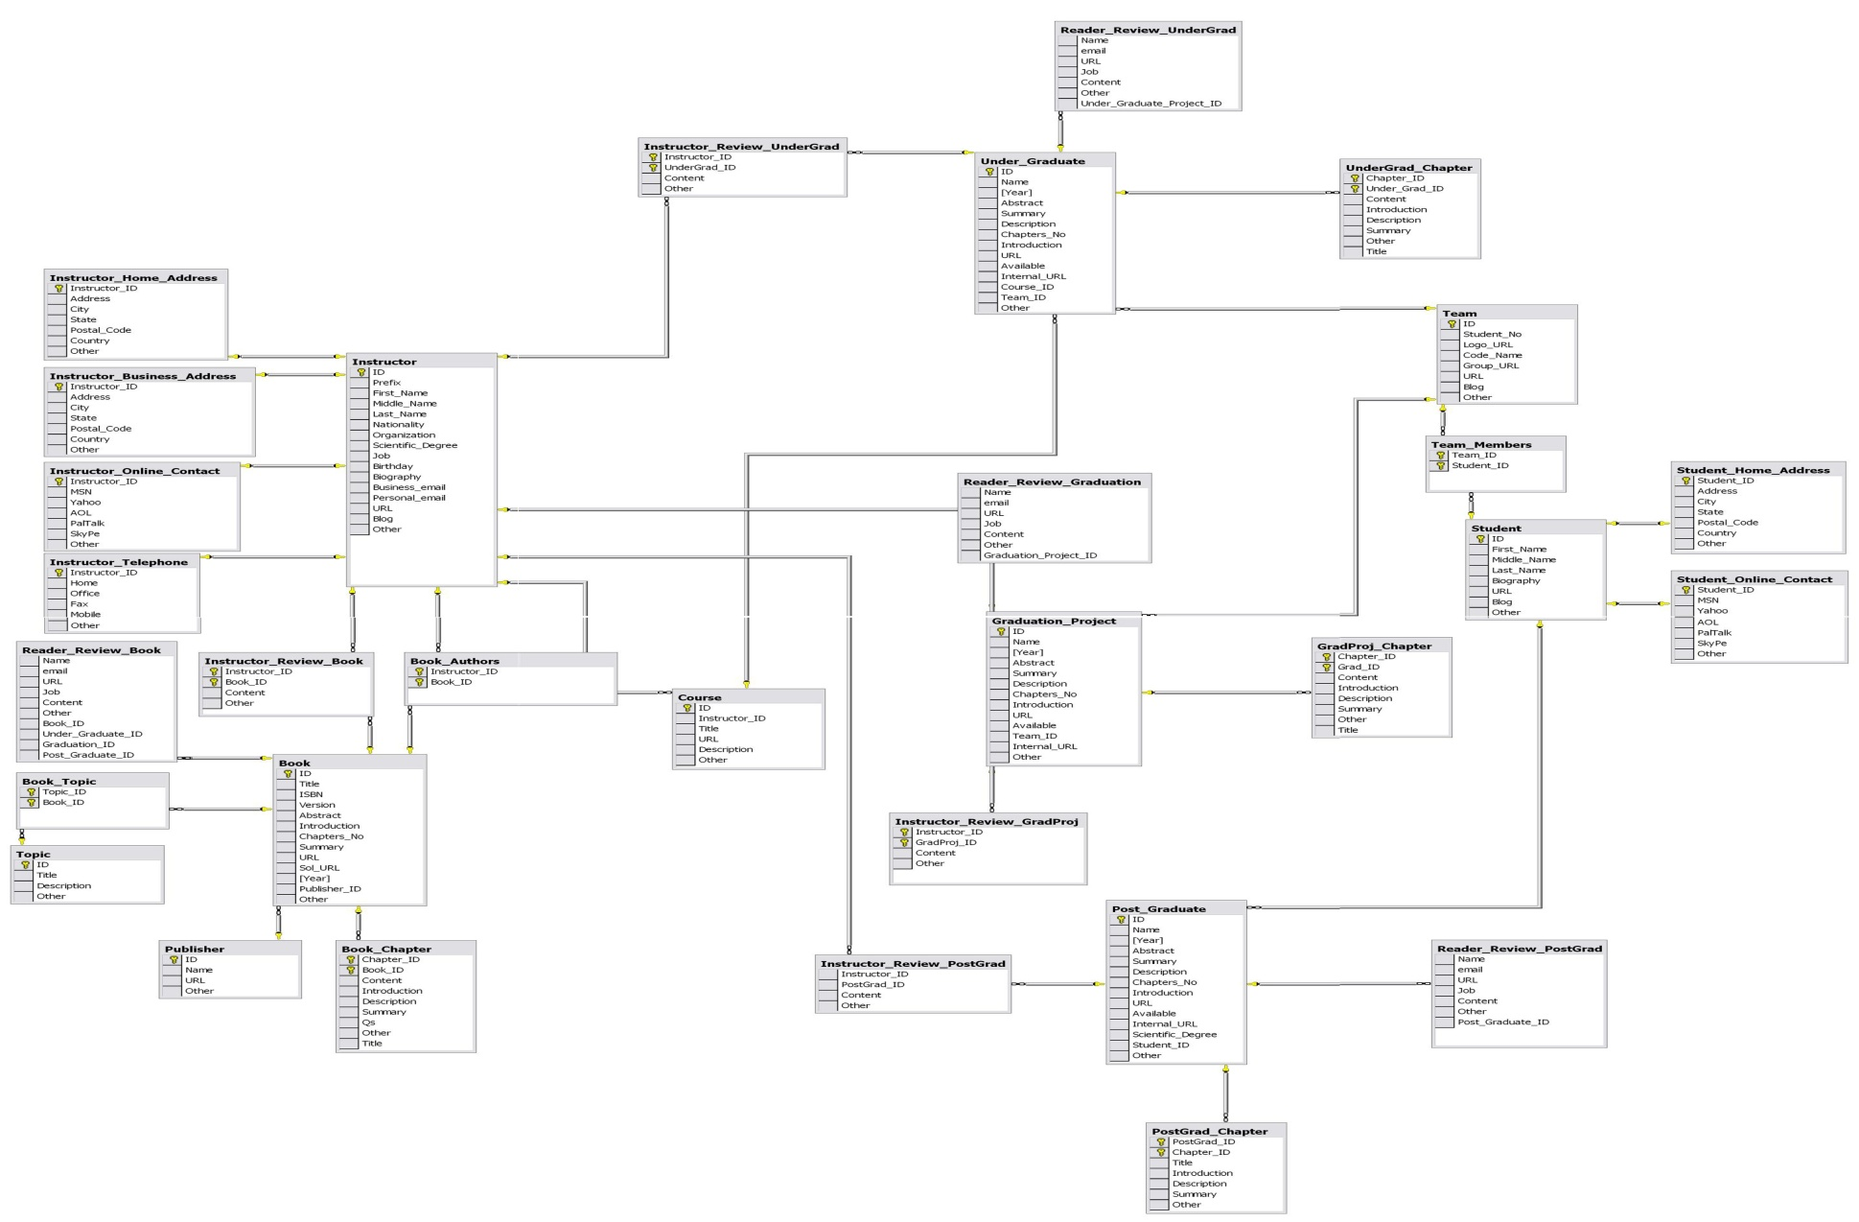

Figure 4.6: Digital Library Database Tables

**4.3 Digital Library Classes**

Figure 4.7 shows the digital library class diagram

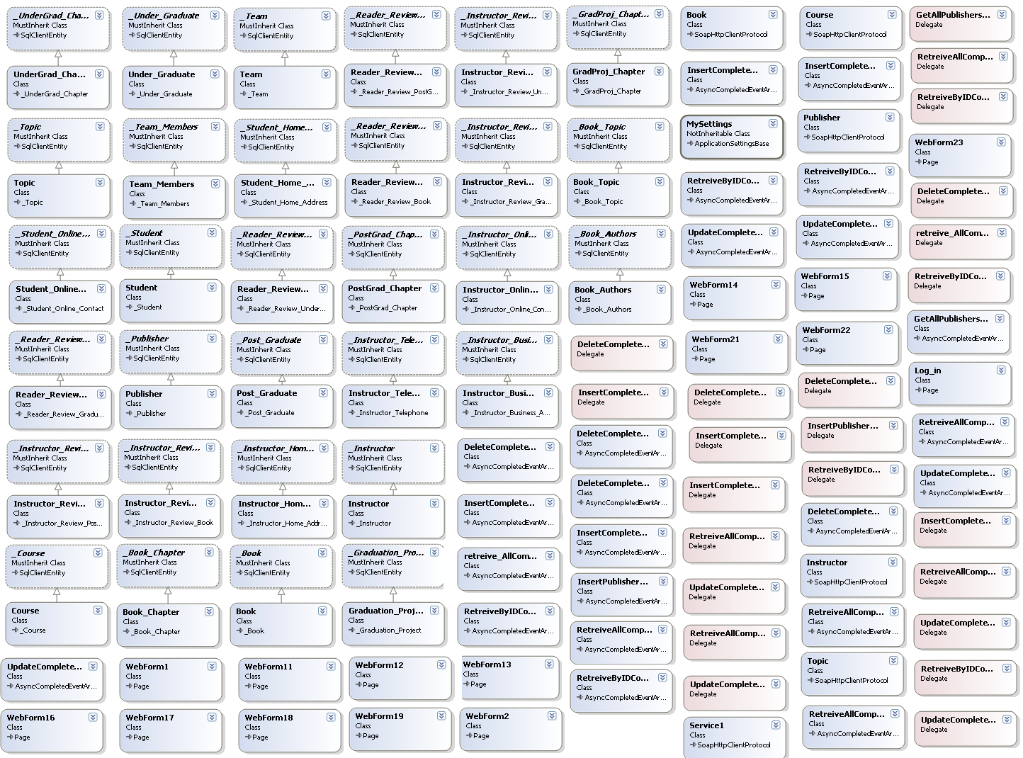

Figure 4.7: Digital Library Class Diagram

1. **Summary**

Digital Library aims to present a digital store for faculty contents that needs to be available for future usage in electronic format. Digital Library can be used to present external available digital books, and digital materials available by the system, like: books authored by internal authors / instructors, under graduate, graduation, and post graduate project’s materials like source code and documentation.